**Project 1 E-commerce System Database.**

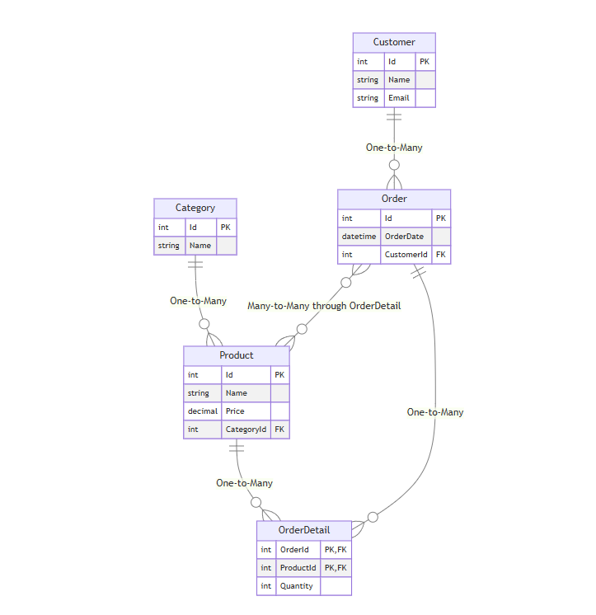

CREATE TABLE Category (

Id INT PRIMARY KEY IDENTITY(1,1),

Name NVARCHAR(100) NOT NULL

);

CREATE TABLE Customer (

Id INT PRIMARY KEY IDENTITY(1,1),

Name NVARCHAR(100) NOT NULL,

Email NVARCHAR(100) NOT NULL UNIQUE

);

CREATE TABLE Product (

Id INT PRIMARY KEY IDENTITY(1,1),

Name NVARCHAR(100) NOT NULL,

Price DECIMAL(10,2) NOT NULL,

CategoryId INT NOT NULL,

FOREIGN KEY (CategoryId) REFERENCES Category(Id)

);

CREATE TABLE [Order] (

Id INT PRIMARY KEY IDENTITY(1,1),

OrderDate DATETIME NOT NULL DEFAULT GETDATE(),

CustomerId INT NOT NULL,

FOREIGN KEY (CustomerId) REFERENCES Customer(Id)

);

CREATE TABLE OrderDetail (

OrderId INT NOT NULL,

ProductId INT NOT NULL,

Quantity INT NOT NULL DEFAULT 1,

PRIMARY KEY (OrderId, ProductId),

FOREIGN KEY (OrderId) REFERENCES [Order](Id),

FOREIGN KEY (ProductId) REFERENCES Product(Id)

);

INSERT INTO Category (Name) VALUES

('Electronics'), ('Books'), ('Clothing'), ('Home & Garden');

INSERT INTO Customer (Name, Email) VALUES

('Ahmed Ali', 'ahmed.ali@email.com'),

('Sara Mohammed', 'sara.mohammed@email.com'),

('Hassan Omar', 'hassan.omar@email.com');

INSERT INTO Product (Name, Price, CategoryId) VALUES

('Laptop', 15000.00, 1),

('Mobile Phone', 8000.00, 1),

('Programming Book', 200.00, 2),

('T-Shirt', 150.00, 3),

('Garden Tools', 500.00, 4);

INSERT INTO [Order] (OrderDate, CustomerId) VALUES

('2024-01-15', 1),

('2024-01-16', 2),

('2024-01-17', 1);

INSERT INTO OrderDetail (OrderId, ProductId, Quantity) VALUES

(1, 1, 1),

(1, 3, 2),

(2, 2, 1),

(2, 4, 3),

(3, 5, 1);

SELECT c.Name as Category, p.Name as Product, p.Price

FROM Category c

JOIN Product p ON c.Id = p.CategoryId

ORDER BY c.Name, p.Name;

SELECT

cust.Name as Customer,

o.OrderDate,

p.Name as Product,

od.Quantity,

(p.Price * od.Quantity) as Total

FROM Customer cust

JOIN [Order] o ON cust.Id = o.CustomerId

JOIN OrderDetail od ON o.Id = od.OrderId

JOIN Product p ON od.ProductId = p.Id

ORDER BY cust.Name, o.OrderDate;

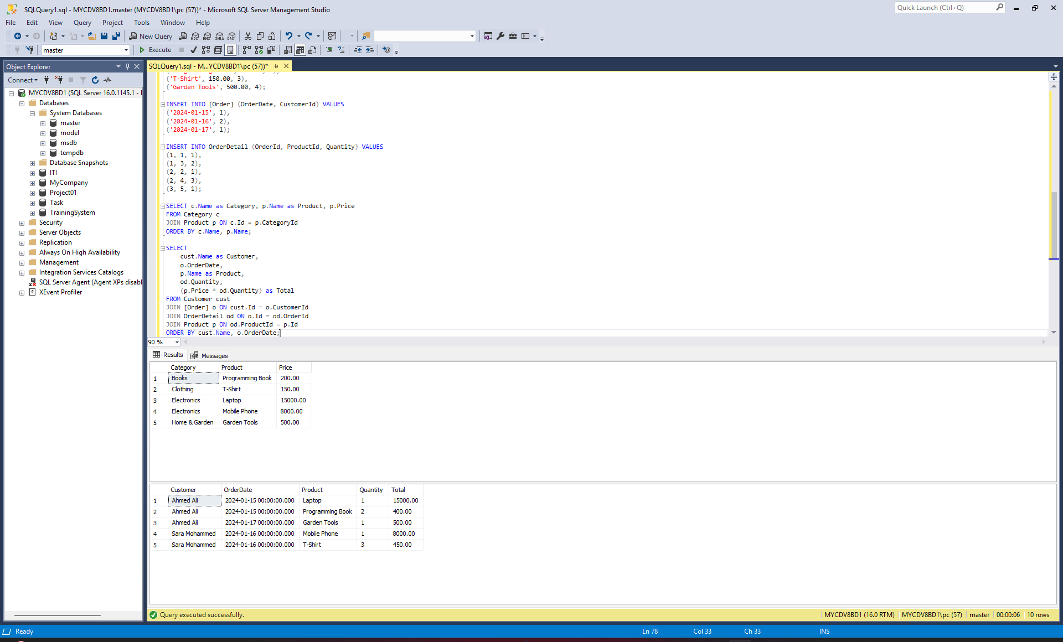

**Project 2 Library System Diagram.**

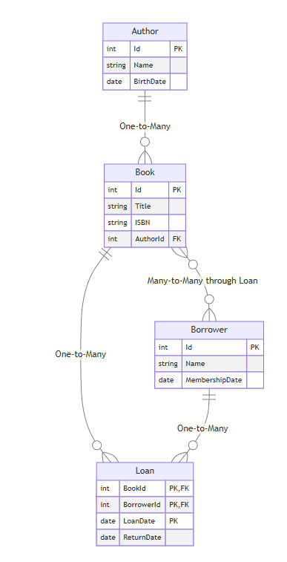

CREATE TABLE Author (

Id INT PRIMARY KEY IDENTITY(1,1),

Name NVARCHAR(100) NOT NULL,

BirthDate DATE

);

CREATE TABLE Borrower (

Id INT PRIMARY KEY IDENTITY(1,1),

Name NVARCHAR(100) NOT NULL,

MembershipDate DATE NOT NULL DEFAULT GETDATE()

);

CREATE TABLE Book (

Id INT PRIMARY KEY IDENTITY(1,1),

Title NVARCHAR(200) NOT NULL,

ISBN NVARCHAR(20) NOT NULL UNIQUE,

AuthorId INT NOT NULL,

FOREIGN KEY (AuthorId) REFERENCES Author(Id)

);

CREATE TABLE Loan (

BookId INT NOT NULL,

BorrowerId INT NOT NULL,

LoanDate DATE NOT NULL DEFAULT GETDATE(),

ReturnDate DATE NULL,

PRIMARY KEY (BookId, BorrowerId, LoanDate),

FOREIGN KEY (BookId) REFERENCES Book(Id),

FOREIGN KEY (BorrowerId) REFERENCES Borrower(Id)

);

INSERT INTO Author (Name, BirthDate) VALUES

('Ahmed Shawky', '1868-10-16'),

('Naguib Mahfouz', '1911-12-11'),

('Taha Hussein', '1889-11-15'),

('Youssef Idris', '1927-05-19');

INSERT INTO Borrower (Name, MembershipDate) VALUES

('Mohamed Hassan', '2023-01-15'),

('Fatima Ahmed', '2023-03-20'),

('Omar Khaled', '2023-06-10'),

('Nour Ali', '2024-01-05');

INSERT INTO Book (Title, ISBN, AuthorId) VALUES

('The Days', '978-1234567890', 3),

('Palace Walk', '978-1234567891', 2),

('The Cheapest Nights', '978-1234567892', 4),

('Shawqiyyat', '978-1234567893', 1),

('Sugar Street', '978-1234567894', 2);

INSERT INTO Loan (BookId, BorrowerId, LoanDate, ReturnDate) VALUES

(1, 1, '2024-01-10', '2024-01-24'),

(2, 2, '2024-01-12', NULL),

(3, 1, '2024-01-15', '2024-01-29'),

(4, 3, '2024-01-20', NULL),

(5, 4, '2024-01-25', '2024-02-08'),

(1, 2, '2024-02-01', NULL);

SELECT a.Name as Author, b.Title, b.ISBN

FROM Author a

JOIN Book b ON a.Id = b.AuthorId

ORDER BY a.Name, b.Title;

SELECT

b.Title as Book,

a.Name as Author,

br.Name as Borrower,

l.LoanDate,

DATEDIFF(day, l.LoanDate, GETDATE()) as DaysOnLoan

FROM Loan l

JOIN Book b ON l.BookId = b.Id

JOIN Author a ON b.AuthorId = a.Id

JOIN Borrower br ON l.BorrowerId = br.Id

WHERE l.ReturnDate IS NULL

ORDER BY l.LoanDate;

SELECT

br.Name as Borrower,

b.Title as Book,

l.LoanDate,

l.ReturnDate,

CASE WHEN l.ReturnDate IS NULL THEN 'Current Loan' ELSE 'Returned' END as Status

FROM Borrower br

JOIN Loan l ON br.Id = l.BorrowerId

JOIN Book b ON l.BookId = b.Id

ORDER BY br.Name, l.LoanDate DESC;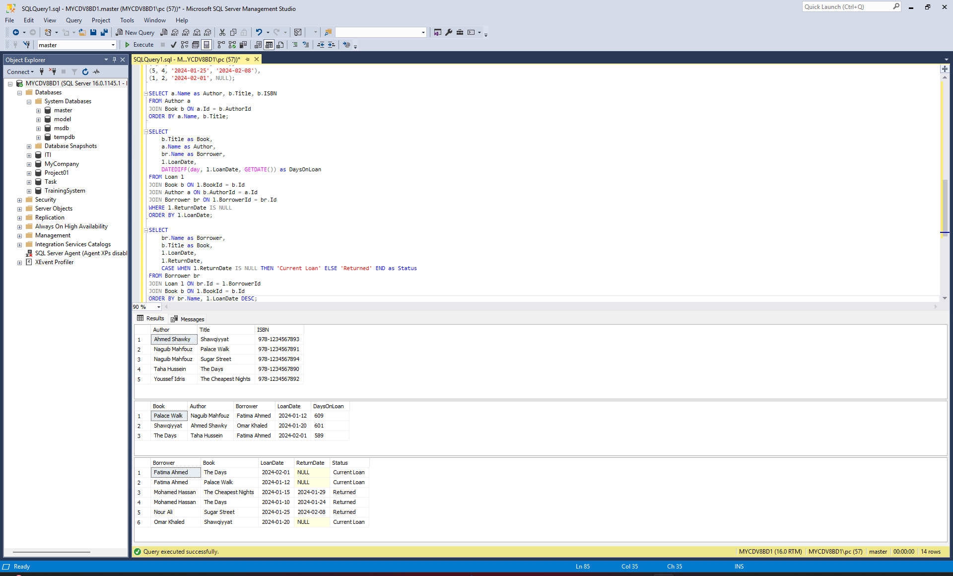

**Project 3 Healthcare System Diagram.**

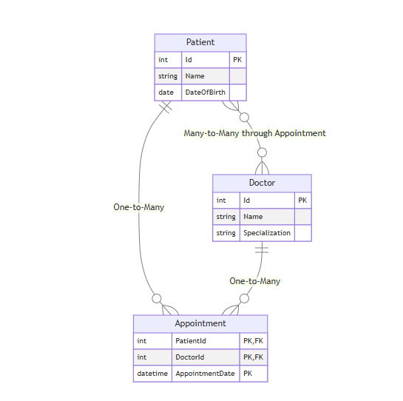

CREATE TABLE Patient (

Id INT PRIMARY KEY IDENTITY(1,1),

Name NVARCHAR(100) NOT NULL,

DateOfBirth DATE NOT NULL

);

CREATE TABLE Doctor (

Id INT PRIMARY KEY IDENTITY(1,1),

Name NVARCHAR(100) NOT NULL,

Specialization NVARCHAR(100) NOT NULL

);

CREATE TABLE Appointment (

PatientId INT NOT NULL,

DoctorId INT NOT NULL,

AppointmentDate DATETIME NOT NULL,

PRIMARY KEY (PatientId, DoctorId, AppointmentDate),

FOREIGN KEY (PatientId) REFERENCES Patient(Id),

FOREIGN KEY (DoctorId) REFERENCES Doctor(Id)

);

INSERT INTO Patient (Name, DateOfBirth) VALUES

('Ali Mohammed', '1985-03-15'),

('Mona Ahmed', '1990-07-22'),

('Khaled Hassan', '1978-12-10'),

('Nadia Omar', '1982-09-05'),

('Youssef Ali', '1995-01-18');

INSERT INTO Doctor (Name, Specialization) VALUES

('Dr. Ahmed Ibrahim', 'Cardiology'),

('Dr. Fatima Salah', 'Pediatrics'),

('Dr. Mohammed Nasser', 'Internal Medicine'),

('Dr. Heba Mahmoud', 'Dermatology'),

('Dr. Omar Farouk', 'Orthopedics');

INSERT INTO Appointment (PatientId, DoctorId, AppointmentDate) VALUES

(1, 1, '2024-01-15 10:00:00'),

(1, 3, '2024-01-20 14:30:00'),

(2, 2, '2024-01-16 09:00:00'),

(3, 1, '2024-01-17 11:15:00'),

(3, 5, '2024-01-25 15:45:00'),

(4, 4, '2024-01-18 16:30:00'),

(5, 2, '2024-01-19 08:30:00'),

(1, 4, '2024-02-01 13:00:00'),

(2, 3, '2024-02-05 10:30:00');

SELECT

p.Name as Patient,

DATEDIFF(year, p.DateOfBirth, GETDATE()) as Age,

d.Name as Doctor,

d.Specialization,

a.AppointmentDate

FROM Patient p

JOIN Appointment a ON p.Id = a.PatientId

JOIN Doctor d ON a.DoctorId = d.Id

ORDER BY a.AppointmentDate DESC;

SELECT

d.Name as Doctor,

d.Specialization,

COUNT(a.PatientId) as TotalAppointments,

MIN(a.AppointmentDate) as FirstAppointment,

MAX(a.AppointmentDate) as LastAppointment

FROM Doctor d

LEFT JOIN Appointment a ON d.Id = a.DoctorId

GROUP BY d.Id, d.Name, d.Specialization

ORDER BY TotalAppointments DESC;

SELECT

p.Name as Patient,

COUNT(DISTINCT a.DoctorId) as NumberOfDoctors,

STRING_AGG(d.Specialization, ', ') as Specializations

FROM Patient p

JOIN Appointment a ON p.Id = a.PatientId

JOIN Doctor d ON a.DoctorId = d.Id

GROUP BY p.Id, p.Name

HAVING COUNT(DISTINCT a.DoctorId) > 1

ORDER BY NumberOfDoctors DESC;  
  
